- Property Booking Process (Done by:Kevin Muho)
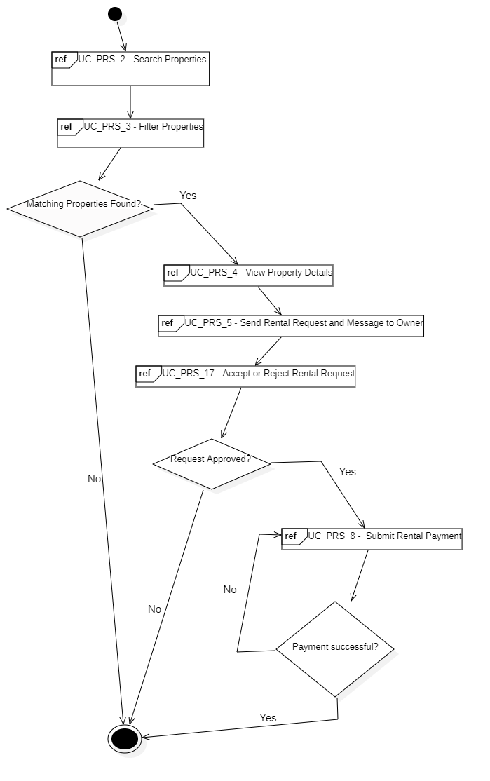

- Property Listing & Managment (Done by:Anisa Domi)
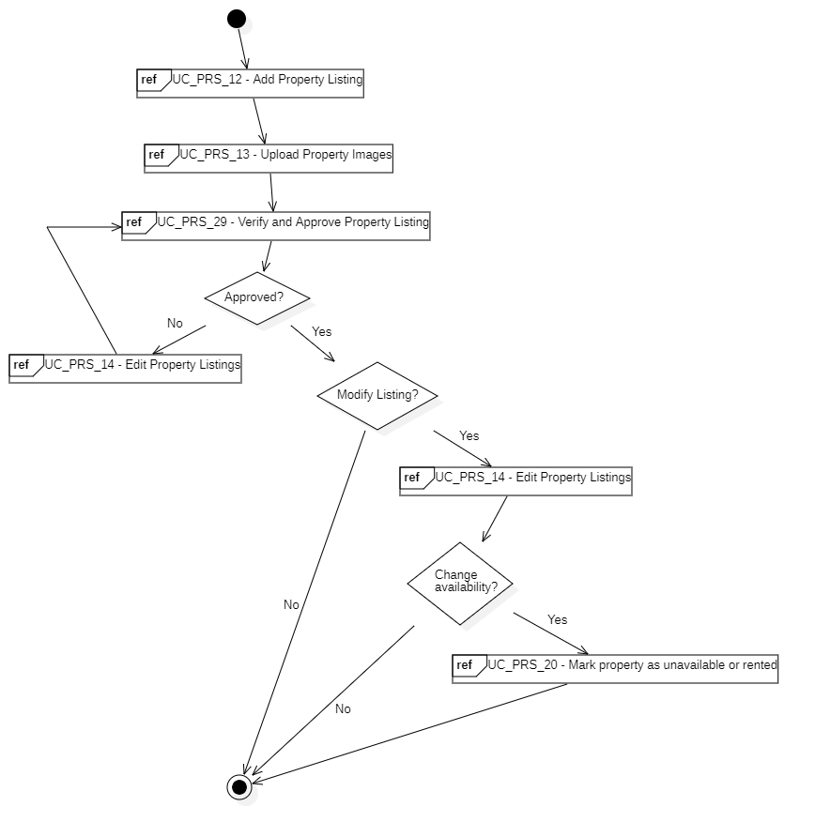

- Complaint & Issue Managment (Done by:Desard Lybeshari)
